GOVERNMRNT COLLEGEKATTAPPANA

DEPARTMENT OF ECONOMICS

Report of Minor Project on “A study on Marginalization of Tea Plantation Workers in Idukki : A Case Study of Peermade Taluk
By

Arunkumar T A

Assistant Professor of Economics

Certificate
This is to certify that the Minor Research project entitled “A study on Marginalization of Tea Plantation Workers in Idukki : A Case Study of Peermade Taluk” is record of original research work carried out by me in the Department of Economics, and further it has not formed the part of any other work submitted.

Kattappana Arunkumar T A
(Principal Investigator)

Preface

One of the specialties of Idukki District is that supremacy of agriculture sector, especially plantation sector. The sector can influence the socio, economic, political and cultural set up of the district. Therefore a study on the sector becomes a greater importance today. Because currently several plantations are undergoing rigorous crisis. A large no of tea plantations has been closed down or abandoned since 1990s. It is not a regional problem. The consequences of such crisis have been experiencing across India. In order to explain the real situations of plantation workers who are relying on abandoned tea estates, the researcher selected the Peermedu Taluk as study area. The taluk plays a significant role in the production of tea in Idukki as well as in Kerala.The tea plantation area of the Idukki district is spread over Peermade, Udumbanchola and Devikulam Taluks out of the total 154 estates of Kerala, central Travancore has 36estates covering 10,100 hectares. There are 36 tea estates, owned by 16 companies, in Peermade Taluk. Out of these, 30 estates run by 12 companies. These estates are spread over Peermedu, Vandiperiyar, Elappara and Upputhara panchayats. Out of total 36 estates about 30 estates are closed /abandoned estates. The situation highlights the importance of the studied problem. The researcher selected one of the abandoned companies in the taluk namely “Peermedu Tea Company” to explore marginalization tea plantation workers in Idukki district. The company and around 3000 workers are the true representation of the victims of crisis that experiences by the concerned communities.

.

ACKNOWLEDGEMENT
This report is the outcome of the research work done in the Department of Economics, Govt. College, Kattappana by me as a part of the UGC Minor Project.
I have immense pleasure in expressing my gratitude to Dr Vishaka Varma, Associate Professor(Retd), Department of Economics, Maharajas College, Ernakulam for his valuable suggestions in all matters related to me work.
I am highly indebted to Dr. Joby Jose, HOD, Department of Economics, Govt. College, Kattapana for his guidance and cooperation.
My friends Dr. V Kannan, Tojy Dominic, Baisil A, Suresh K and Vishnu Sadasivan helped me immensely in spite of their own busy routine work. I cherished their varied and sincere advices in different stages of carrying out this work.
I take this opportunity to express my thanks to staff of Tea Board, Kottayam, District Labour Office, Idukki, Office of the Chief Inspector of Plantations, Peermade, Grama Panchayath Office, Upputhara, who were helpful in providing necessary data and information on the related topic. I extend my sincere thanks to Management staff of Peermedu Tea Company estates and trade union leaders for all sorts of help during field survey and secondary data collection. It is only due to their help this work has come to this form. The tea workers of Peermedu Tea Company are appreciably cooperative to me. I extend my grateful thanks to all of them.
I express my sincere thanks to the students of Department of Economics, Govt. College Kattappana for helping data collection.
Last but not least, I do not have words to express my affection to my family, especially my wife Anija Arun, and my son Udaynath Arun who always supported me to do such a creative work in my life.
Arunkumar T A

CONTENTS
List of Tables
List of Figures
CHAPTER I 1-7
INTRODUCTION

1.1 Statement of the Problem 2
1.2 Objectives 3
  - Methodology 4
  - Importance of the Study 4
  - Area of Study 5
  - Sample Size 6
  - Scheme of Study 6
  - Period of Study 7
1.13 Limitations of Study 7
CHAPTER II 8-12
REVIEW OF LITERATURE
CHAPTER III 12-19
AN OUTLINE OF CLOESD DOWN / ABANDONED TEA ESTATES IN PEERMEDU
3.1 Introduction 12
3.2 Key Reasons for Sickness /Closure
3.3 Overall Profile of Closed Tea Gardens in Peermedu Taluk 14
3.4 A profile of Peermedu Tea Company 16

CHAPTER IV 20-26
PERFORMANCE OF INDIAN TEA INDUSTRY DURING POST AND PRE REFORMS PERIODS
4.1 The Impact of Economic Reforms on India’s Tea Industry 20
4.2 The present status of India in World Tea market 21
4.3 Trend of Production and export of Tea during Post Reform
A profile of Peermedu Tea Company 23
4.4 Decadal changes in area, production and productivity of tea
in India 25
CHAPTER V 27-41

SOCIO ECONOMIC CONDITIONS OF TEA PLANTATION WORKERS DURING POST CLOSURE PERIOD
5.1 Introduction 27
5.2 Age-wise Distribution of employed members of Sample Workers’
Households 28
5.3 Educational status of Sample family Members 29

5.4 Community wise Distribution of Sample Households 30
5.5 Share of Different Sources of Income of Sample Households 31
5.6 Residential facilities 33

5.7 Indebtedness of workers 35

5.8 Non-Payment of Wages 36

5.9 Problems faced by the workers after closure 37
CHAPTER VI 42-46
FINDINGS, SUGGESTIONS AND CONCLUSIONS
6.1 General Information 40
6.2 Educational Status 40

6.3 Community wise Distribution of Workers 40

6.4 Present Income sources of Plantation workers 40
6.5 No scope for additional income generation opportunities 41
6.6 Non-Payment of Wages and other Benefits
6.7 Interim alternative resolution 41
6.8 Poor residential facilities 41
6.9 General observations on vulnerability of Closed Tea Gardens 41
6.10 Suggestions 43
6.11 Conclusions 43

LIST OF TABLES
3.1 Percentage share of tea production in Idukki to Kerala 14
3.2 An outline of Tea Plantations in Peermedu Taluk 15
3.3 The Property status of Peermedu Tea Company 18
4.1 Tea Production and Export share of India during 2015-16 21
4.2 Trend of Production and export of Tea during Post Reform 24
in India
4.3 Decadal changes in area, production and productivity of tea 26 . in India
  - Age-wise Distribution of employed members of Sample 29 Households
  - Educational status of Sample family Members 30
  - Community wise Distribution of Sample Households 31

Chapter I

Introduction
The study is concerned with the pathetic situation of plantation workers in Idukkki district, Kerala. Currently Indian tea sector is undergoing a severe threat that is increasing number of close down or abandoning of tea plantations. The Indian states like Kerala and West Bengal have been facing this seriously for the last few years. The present study is an attempt to explore the impact of such issue on the lives and livelihoods of tea plantation workers those who are living in lines (residential facilities provided by the management). In order to explore the real difficulties of tea plantation workers the researcher selected the case of Peermedu Tea Company. The company is located in Upputhara panchayath which is the part of Peermedu taluk. Peermedu is known as the tea pot of Kerala, is one of the most important tea producing regions in South India. Tea Industry is one of the oldest organized firm sectors with a large network of tea producers, retailers, distributors, auctioneers, exporters and employees. India is one of the world’s largest producers and consumer of tea. In spite of its importance, the recent economic crisis largely followed up on neo liberal economic reforms in Indian tea industry that led to temporary closure of many plantations further deteriorated their life. Consequently the industry has witnessed many structural changes during recent years, which include – emergence of small tea growers in place of large plantation and introduction of bought leaf factories (BLF). Besides workers of the running estates are facing wage cut, tougher picking demand, job insecurity and the casualisation of work, appalling living and working condition etc. Moreover abandoning of tea estates is universal issues numerous numbers of families have been migrate; they have lost their shelter, traditional occupations and the benefits derived from the surroundings of estates. They were never properly compensated. This new situation became a crucial moment for the plantation workers as it put them in an unusual situation where they have to cope- up, renegotiate, and rethink their life in relation to the crisis. It is evident that, in the case of four major tea producing states in India namely West Bengal, Assam, Tamil Nadu and Kerala, where the crisis was deeper in its impact.

In the case of Kerala, notably in the Peermade tea belt (focused study area), the crisis is more visible. Many of the tea plantation workers were forced to seek other work outside the plantations. The existence of vast underemployment in tea plantation sector becomes a crisis, especially for women workers. The youth resorts mainly on unorganized sectors for their employment opportunities and many of them are working in least preferred professions like driving, automobile repairing, tailoring, sales in retails market, and home nursing. But most of workers and their families, who had nowhere to go in search of jobs, had to stay back in the plantations. In the case of abandoned plantations and partially working plantations the workers are getting only subsistence wage. The continuous rise in cost of living along with a series of economic reforms, utter poverty, unusual changes in climate, poor standard of living, shattered social life or community relations, withdrawal of certain welfare measures by the plantation owners are the disruptive factors of their normal life and such situations facilitate to marginalize these people from the mainstream society . In such a situation the study on problems of tea plantation workers and their deprivation become significant. To a certain extent the trade unions and political parties are failed to support the plantation workers. The protest and strikes of women tea workers in Munnar region proved that fact.

1.1 Statement of the Problem
The plantation industry is an important agriculture based industry in Kerala. It plays crucial roles in income generation, foreign exchange earning and employment generation both directly and indirectly. The number of closed down plantations have been increasing vastly in all over India. However plantation workers have been struggling to meet their day to day needs. It is the same case for Peermedu Tea Company, the study area. It was closed down during 2000. The plantation Tamils, as they are known locally belong to Dalits (ex touchable or outcaste) communities who have been segregated within Indian society and were and kept out of socio economic progress for centuries. In most tea estates there are many bottlenecks. Data about the wages paid to workers reveals that the agricultural labourers do not receive notified minimum wages except in certain parts of India. In addition to these the sector suffers from low productivity, delayed payment of wages and other benefits, low profit, lack of proper marketing system, poor standard of living, exploitation…etc. These are common problems that exist in tea sector. Furthermore abandoning of tea estates or closing down of estates deepening the problems of tea plantation workers. Nearly all of trade unions fail to protect the interest of workers. Finally the so called economic reforms and it impacts also cause to worsen the community. Recent reform like demonetization in India has also created havoc in the industry. The weekly wages paid to labourers have more or less stopped since the implementation of demonetization. Even though there were many agitations and popular movements to tackle this situation in Idukki, all of them failed to achieve declared objectives. But these types of movements are viewed as starting point of new type of protest against existing situation.
The only income for plantation workers is the wage income, from either permanent or temporary work in the plantations. Once the plantations fail to provide wages, workers have to face severe problems. The closure of Peermedu Tea Company in the year 2000 pushes the workers to the verge of starvation and a feeling of helplessness in meeting the essential requirements of living. Many of them are struggling to meet even essential food items, expenses related to education for the students like school uniforms, paying fees, purchase of educational items, expenses related to health problems of physically challenged and sick among them. In short plantation workers in Kerala represent a community totally marginalized in all respects. And they are dissatisfied with present system. The response of the workers during field visit has cemented the fact that the benefits of any reforms in India are not getting properly.

1.2 Objectives of the study.

The study is mainly focused to explore the pathetic situation of tea plantation workers in the study area. And it also stresses to identify and delineate the changing nature of the alienation and marginality of plantation workers in a globalised era. The study purports

i) To explore the impact of recent reforms on the tea plantation industry in India.

ii) To assess the living condition of tea plantation workers in the study area.

iii) To explore major problems faced by the tea plantation workers during post closure period of tea estates.

1.3 Methodology
The proposed study is a micro level study at taluk level. It is based on both primary and secondary sources of data. The major share of total tea production of Kerala is from Idukki district, particularly Peermedu region. In the analysis of impact of reforms on plantation industry researcher mainly depended on secondary sources of data such as reports of Tea Board, UPASI, State Planning Board, Association of Planters of Kerala, different tea companies Research Reports.etc.
In order to reach the second and third objectives researcher used survey method inside the tea plantation estates of Peermedu Tea Company. A questionnaire was given to the workers and was asked to respond to the questions related to problems and poor standard of living of the Tea plantation workers. The living conditions and employment opportunities in the study area are closely examined. The land area, personal data, family background, working conditions, per capita income, housing condition, educational status…etc were taken as the indicators of the general living condition of tea workers.

1.4 Importance of the Study
The phenomenon of abandonment or closure of tea estates becomes common in Kerala. Plantations are main stay of Kerala's economy, particularly in rural sector. The closing down of estates and tea factories adversely affect the overall performance of economy of tea producing state. The problems of tea plantation workers are multidimensional in nature. Kerala Model of Development is an ideal label that refers to Kerala’s outstanding performance in many human development indicators which could be equated with developed countries like Norway and the U S even in the midst of very lower per capita income relative to other Indian states (Sen 2001; Franke and Chasin 1989; Heller 1999). However plantation workers are excluded from these so called Kerala Model of Development. The foregoing history of the plantation workers explores that they are always remained an underclass were kept in the same position in colonial period as well as the post colonial regimes. Currently we are undergoing a series of economic reforms. But their effects are not hopeful to the plantation sector. The standard of living of plantation workers especially who are living in lines is worsening day by day. The United Planter’s Association of Southern India (UPASI), the apex body of planters of Kerala, Karnataka and Tamil Nadu, has made it clear that the demand for a daily wage of Rs 500/-by the tea plantation workers of Kerala is not feasible given the current economic realities and plethora of taxes and levies and in case it is forced up on them, it will lead to collapse of the sector (Economic Times, September 29, 2015). That is, the demand for raising basic wage in the sector is not possible. Compare to other sectors the lowest wage level is prevailed in agriculture sector.

1.5 Area of Study
Idukki district is one of the major tea hubs of Kerala. The tea plantation area of the district is spread over Peermade, Udumbanchola and Devikulam Taluks out of the total 154 estates of Kerala, central Travancore has 36 estates covering 10,100 hectares (29.1 percent of total tea area of state) of area and employing 26,000 workers. An equal number were also enlisted in these estates as temporary workers. These estates owned by 16 companies are located in Peermade Taluk. These estates are spread over Peermade, Vandiperiyar, Elappara and Upputhara panchayats. Among the tea estates the researcher studies the issues in Peermedu Tea Company. Because, among the closed down or abandoned tea estates in peermedu taluk, Peermedu Tea Company has the highest rate of employment reduction after the closure of the company. The data shows that 78% of employment reduced due to the closure of the company during 2000. The area of Peermade Tea Company has 1029 hectares of land. It is located in 6 and 12 wards fully and 7,11and 15 wards partially of Upputhara Panchayath. The entire region around Upputhara remained uninhabited till about the early part of the 20th century. Upputhara was one of the regions to which migration of farmers from other parts of Kerala first took place. A group of seven Christian households came to Upputhara in 1910 from the Meenachil taluk of Kottayam district after acquiring licence from the Government of Travancore to establish tea plantations. The first migration was to begin cultivation of crops outside the plantation. This type of migration to regions outside the plantation segment was mainly steered by a policy of the Government of Travancore to distribute pattas (possession rights) to migrant farmers in previously uninhabited areas, the largest flow of migrants into Upputhara and its surrounding regions took place in the 1950s.Farmers who migrated into Upputhara after the 1930s were primarily involved in the cultivation of coffee, pepper and a few tuber intercrops. Tea was cultivated only in large plantations. From the cultivation of only a few crops in the 1950s, the cropping pattern in Upputhara became diversified significantly by the 1990s.

1.6 Sample Size
The workers of Peermedu Tea Company are the target population of the study. In the company there were 1300 permanent workers along with equal number of temporary workers before the closure of company. But today the number of permanent workers has been contracted to 493. Many of the workers have been migrated to other districts and Tamil Nadu. Thus from total population of 493 permanent workers researcher selected 341 workers as sample. For the completion of study the researcher surveyed 90 families. There is no record having exact number of workers in the study area after the closure of estate in 2000.
Before the closure there was equal number of temporary workers. In the study researcher randomly selected permanent workers from four divisions of Peermed Tea Company. Various studies reveal that there is a high level of migration in abandoned tea gardens. Men, in general, have taken up work in unorganized sector such as road tarring, excavation for cabling, construction and daily wage agricultural work. Many men also work in nearby towns such as Kottayam and Ernakulam. Some Tamil men have returned to Tamil Nadu in search of jobs.

1.7 Scheme of Study
The study consists of six chapters. The first chapter is an introduction chapter where a brief account of the relevance of tea economy of Kerala abstract of the present crisis in tea industry and its impact, the importance of present study, objectives of the study, description of study area and methodology of study are given. The second chapter contains various study related to tea plantation sector generally in India and particularly in Kerala. Third chapter focussed to provide an outline of abandoned tea estates in Peermedu. The performance of Indian Tea sector post and pre reform period, the position of India tea market in World tea market, the problems and socio economic conditions of tea workers analysed in chapter four.An analysis of primary investigations conducted in Peermed taluk specifically in the tea estates of Peermedu Tea company is included in fifth chapter.. . The sixth chapter gives the summary, conclusions and suggestions of the study.

1.8 Period of the Study
The present study covers the period from 2000-2016 December. The unhappiness of tea plantation workers of Peermedu Tea Company was started in 2000 when the owners abandoned the company. Before the closure the workers were more or less satisfied with their life. But their life was deprived unexpectedly and they could not slaughter their pathetic life till the date. The problems that have been experiencing by the workers arises only because of the recalcitrance attitude of managers replied some old agers during field visit. Initial period after the closure of the company situations of workers were not severe as that today.

1.9 Limitations of the study
In spite of detailed analysis made in the present study, this study is not free from limitations. The following are the important limitations: i. The study is purely based on the views of 341 respondents only and hence the results may not be universally applicable. ii. The geographical area of this study is confined only to Peermed Taluk, Idukki district, Kerala. iii. The study is period specific. iv. The survey is collected from four tea estates of Peermedu Tea Company. v. The limitations of this method are applicable to this study. Vi. The unwillingness of respondents to explain their situations. Vii. Lack of proper record regarding the actual no of workers at present.

Chapter II

Review of Literature

Plenty of studies were undertaken in tea sector by individuals, research organizations, state and central governments. Every effort was made to locate the available literature related to the tea plantations especially the studies focused on the abandonment and/or closure. An overview of the literature reviewed is given below. The literature reviewed was included the issues related to abandonment and its impact on tea plantation sector in Kerala with special reference to Peermed taluk. The taluk is popular on its geographical specialties as well as abundance of tea plantations.

A study conducted by Wickramasinghe & Cemeron, 2002 found that in tea plantations there are existing politico-cultural production relations. It is dominated labour productivity. This culture of the plantation community adversely affects the smooth operations of plantations. Therefore social capital development in tea plantations is necessary not only for productivity improvement but also for reasons of political and social obligation for the nation, because migrant plantation workers have been working and living in the plantations over a long period of time.

Kagira, Kimani, & Githii studied the challenges facing the small holder tea sector in Kenya in 2012. They analysed supplier and customer relationship, value addition, information technology, information sharing, flexibility in internal operations , upgrading of tea seedlings, proper coordination, institutionalization, policy reforms, training, monitoring marketing environment, strategic decisions ...etc. In addition to these the study also detailed irrigation, venturing into new market through partnership and civil society involvement as competitive supply chain strategies in the face of declining and shifting competitiveness of the small holder sector in Kenya.
An analysis made by Chaudari, in 1978 to examine the influence of the low price of land and labour in India tea industry. It revealed that land for operation is available at low price but the productivity and performance o f plantations are not up to the mark. It is argued that this sector requires an extensive cultivation practices.

M.G. Srinivasan conducted a case study in Nilgiri District Tamil Nadu to explore the problems of tea plantation workers in 2016. It suggested that the tea Plantation Industry has to be brought under one Ominous Legislation and a separate committee with judicial power has to be formed to regularize it on the other hand the Government has to be allotted to conduct research, Training, Re-Plantation in this sector. A separate Board has to be established for the Welfare of the workers and foreign helpful methods and comparison of the same has to be introduced with immediate effect. The study also found that tea workers in Nilgiri District are paid very less and least beneficiary measures are given to them. He also added that there are many theories available explaining labour welfare and related issues. But the authorities as well as the policy makers are not aware of such knowledge. The workers in the sector have been experiencing injustice which should be come under the law of violation of justice.
Milindo Chakrabarti and Animesh Sarkar, concentrated on the problems of Chongtong Tea Estate, closed estate in Darjeeling. The study examined migration, women problem, and status of basic facilities after closure, wage, and the role of trade unions in tea estates. It reveals that the workers are not receiving any benefits from the authorities. Though majority of them are BPL category they are not getting benefits. The local body government supplies less amount ( 1 KG of each ) of wheat and rice twice in a week. It is argued that there will be institutional arrangement for tackling the issues.
The main inefficiencies that existed in tea industry are the feudal relationship between the employers and the workers. Because of these relations all most all employers deny the rights of workers. Under these conditions the employer could not ready to accept the workers as an asset (Bhowmik S. K., 1996) Thereby this sector fell down in crisis.

Krishnan, 2001 indicates that today the plantation industry concerns spin around prices and costs. It has performed badly yet again and is facing its worst crisis ever in consumption, export and quality terms. If the price uptrend currently being witnessed is sustained there may yet be some spirit left in the industry.

The financial support by the govt. for reopening tea plantation is unnecessary. Most often the owners of plantations divert these funds for another purpose. Therefore this assistance will not be a permanent solution (Bose J., 2007). Moreover the tea board and other government agencies supposed to support and promote right measures to shift the teas into organic tea. By this means tea can demand higher prices in the national and international market. Thus tea can assure superior price as well as deserved remuneration to workers.

K.N. Nair and R. Ramakumar examined the agrarian distress and its impact on the different socio-economic groups in Upputhara Panchayath, Idukki District, and Kerala in 2007. It also analysed the strategies of livelihood adopted by households and the local institution to handle the issue. They elaborated diversification cannot not be considered as a strategy for reducing distress. Introduction of diversification in agriculture without looking at its long term impact may adversely affect the household livelihood system. The findings of the study also criticize the present analytical framework of the sustainable livelihood approach. In the context of the present study in Upputhara, they concluded that livelihood risks require a revision of the policies of agricultural trade liberalisation, ensuring the availability of agricultural inputs to farmers at reasonable prices, raising the levels of public investment in agriculture, and the establishment of a comprehensive social security system for the population. For that there should be a paradigm shift of trade policies, livelihood approach of local authorities and households.

In the changing scenario of the Indian tea industry, the study prepared by Saji M Kadavil, tried to understand how Indian tea plantations accomplish their CSR practice at international standards and strengthen and move the international value chain of tea industry. The study also looked at various attempts to move to multi crops and other Indian Tea Research farming business include retail agri market emerging as a new business model in the Indian tea industry. The study also looked at how CSR is being practiced and how it leads to the business model of achieving high productivity and competitiveness at international standards.

The present salary for women tea workers is inadequate to run their family (A Mahalakshmi, 2012). It was an in depth study is conducted to find the socioeconomic status of women employees in South Indian Tea Industries. In order to analyse socio economic conditions of women workers researcher encloses living condition, Employment status, earning, wages and benefits of women workers.

Techno Economic problems have been analysed with remedial measures for uplifting the tea plantation sector. Tea plantation provides livelihoods to a large no of population in the state. For a long period of time tea sector in Kerala have been facing a host of problems like low profitability, inadequate investment, Entrepreneurial inadequacy …etc. The different levels govt authorities and other institutional level effort is synchronized to tackle the crisis in the sector (Sanjoy Kumar Mitra, 2011).

Nair (1989) examined socio economic conditions of labourers in Ponmudi Tea estate unit which is closed since 1973.It was a case study to explore the pathetic situations of tea plantation workers. Though the plantation workers experience poverty and unemployment they continue within the estate because they do not have other option.

Chapter III

An Outline of Closed down/ Abandoned Tea Estates in Peermedu

3.1 Introduction
As per an official Census 2011, Idukki had population of 1,108,974 of which male and female were 552,808 and 556,166 respectively. In 2001 census, Idukki had a population of 1,129,221 of which males were 566,682 and remaining 562,539 were females. Idukki District population constituted 3.32 percent of total Maharashtra population. In 2001 census, this figure for Idukki District was at 3.55 percent of Maharashtra population. There was change of -1.79 percent in the population compared to population as per 2001. In the previous census of India 2001, Idukki District recorded increase of 7.03 percent to its population compared to 1991. Idukki plays a significant role in the production of tea in Kerala. The socio, economic, cultural and political set up of Idukki are directly linked with the plantation industry.
3.2 Key Reasons for Sickness / Closure
The high-range district of Idukki in Kerala is spread across a total land area of 4,476 square kilometers, which is 12.9% of the total area of the state. With almost 11.25 lakh population the major earner for people is agriculture. The major crops grown in the region are tea, coffee and spices. Tea is the major activity that provides close to 50 per cent of the direct and indirect employment in the region. Actually the crisis in the tea sector started in the 1990s. It was only because of fall in tea prices. Other manifestations of this crisis include decline in exports, closure and abandonment of tea gardens, increasing labour unrest at times leading to violent protest and confrontations, non-payment and curtailment of wages and other statutory benefits of workers, declining labour standards and excessive dependence of workers’ existence on plantation economy (Kingshuk Sarkar (2015) , NRPPD Discussion Paper. It resulted significantly in the economy as a whole and altered the lives of nearly 40,000 people directly and 2 lakh people indirectly (Jacob Jose, CEC, 2007). But Indian Tea Board reported that the key reasons for sickness / closure can be attributed to:
- Poor yield
- Ageing bush profile and high vacancy
- Negligible (usually nil ) uprooting / replanting
- Poor garden management practices, Falling quality and price realizations
- Uneasy (though usually not volatile) industrial relations scenario
- Overall lack of development perspective
- Highly debt oriented funding strategy,
- Ownership dispute.
Though the management blamed labour unrest for the abandonment, actual reasons were mismanagement and a lack of interest in the tea business accused by plantation workers. The management also has interests in other plantation crops such as rubber cardamom and pepper (Jose Jacob, 2007). Another strong belief related to the closure of tea plantation is higher cost of production. In India tea industry’s survival depends on the wage rate prevailing at the plantation. Labour cost is the most significant component of the cost structure and the planters had no control on the prices of inputs other than labour. Thus, planters tried to keep wages as low as possible. But the crisis in tea plantations cannot be generalised .
The present chapter gives an overall picture of closed or abandoned tea plantations in peermedu Taluk, Idukki district, Kerala. As explained earlier it is a micro level study. In tea plantation sector of India southern states especially Kerala plays crucial role. In SouthIndia, Tamil Nadu, Kerala and Karnataka are the major tea growing states contributing 65.66, 32.48 and 1.86per cent respectively (Merlin Joseph, 2002). In Kerala tea growing districts are Idukki, Wayanad, Kottayam, Kollam, Thiruvananthapuram, Trissur, Malappuram and Palakkad. Though tea is grown-up in all these districts there is substantial spatial attention in two districts, Idukki and Wayanad. They account for about 87.24 percent of the total tea area of Kerala, Idukki has 72.40 percent and Wayanad has14.84 per cent of tea growing area in the State (Tea Board, 2011).
An analysis of the trend of tea production Idukki is essential to evaluate its role in total tea production in Kerala. Data shows that about 77 % tea production was from Idukki district during 2010-11. The highest contribution 78% was in 2009-10. These figures underline the significant role of Idukki in the sphere of tea production in Kerala. Among all the districts in Kerala, Idukki has the highest level of Net Domestic Product (NDP) from agriculture. Idukki also records the highest per capita income, Rs 26,028 in 2000-01 among all the districts in Kerala, the corresponding State average being Rs 19,951(K N Nair and Ramakumar, 2007). The following table deals with the share of Idukki to total tea production in Kerala during post reform period.
Table 3:1 Percentage share of tea production in Idukki to Kerala
Year | Production in (Tonnes) |  | % of total production in Kerala
Year | Idukki | Kerala | % of total production in Kerala
2005-06 | 40063 | 56384 | 71
2006-07 | 36229 | 53659 | 67
2007-08 | 37108 | 51754 | 71
2008-09 | 36952 | 51726 | 71
2009-10 | 45162 | 57810 | 78
2010-11 | 44192 | 57291 | 77
Source: Census 2011

3.3 Overall Profile of Closed Tea Gardens in Peermedu Taluk.

The crisis in tea industry has seriously affected the tea estates in Peermade Taluk, the study area, as in all the tea cultivated regions in the nation. The tea plantation area of the Idukki district is spread over Peermade, Udumbanchola and Devikulam Taluks out of the total 154 estates of Kerala, central Travancore has 36estates covering 10,100 hectares (29.1 percent of total tea area of state) of area and employing 26,000 workers ( T V Usha Devi , V N Jayachandran 2003). There are 36 tea estates, owned by 16 companies, in Peermade Taluk. Out of these, 30 estates run by 12 companies. These estates are spread over Peermedu, Vandiperiyar, Elappara and Upputhara panchayats. The first 30 estates mentioned in the table are closed /abandoned estates. The table also shows that reduction in employment opportunities due to the closure of estates. One of the most important problems that India has been facing since independence was unemployment. It is still continues as major threat to our fastest growing nature of the economy. Since the post reform period it was more convincing. Here the repercussions of reforms along with inherent situations of tea plantations the problems of workers intensified. It is evident from the table (2.3)

Table 3.2 An outline of Tea Plantations in Peermedu Taluk
Name of the Company | Name of Estate | Area in ( Hectares) | No of workers in 2000 | No of workers in 2016 | Percentage Reduction in Employment
1. Peermade Tea Company | 1.Peermade 2.Lone Tree | 1029 | 1826 | 493 | 73
2.Poabson Estate | 3.Manjumalai  4.Pambanar  5.Nellickal  6.Thengakal | 1408.2 | 3053 | 1482 | 51.45
3.A V George Company | 7.StagbrookAshly | 539.11 | 362 | 192 | 46.96
4.R B T I and II | 8.Tungumullai  9.Pasumallai  10.Granby 11.Mount  12.Koliekanam | 1550.02 | 2686 | 1522 | 43.3
5.Churakkulam Estates (MMJ) | 13.Kottamali 14.Bonami  15.Vagamon  16.Churakulam | 1254.92 | 2050 | 690 | 66.34
6. Mlamallai Estate | 17.Mlamala | 227.18 | 400 | 125 | 68.75
7. Haileyburia Estates | 18.Hailyburia 19.Chinnar  20.Seminivalley | 742.05 | 1810 | 675 | 62.7
8. Chandravanam | 21.Chandravanam | 93.28 | 117 | 46 | 60.68
9. The Karimthuruvi Tea Estate Ltd. | 22.Karintharuvi  23.Penshurst | 377.07 | 600 | 417 | 30.5
10. Aban Loyd Ltd. | 24.Tyford | 980.21 | 650 | 486 | 25.23
11. Harrison Malayalam Ltd. | 25.Moongalar 26.Wallardi  27.Pattumalai | 1614.18 | 2920 | 1638 | 43.9
12. Hope Plantations | 28.Glenmary 29.Ladrum  30.Koduakaranam | 1319.51 | 2519 | 1233 | 51.05
13.Alampally | 31. Alampally | 173.94 | 270 | 135 | 50
14.A V Thomas Company | 32.Arnackal  33.Carady Goody  34.Pasupparai | 1836.91 | 3528 | 1498 | 57.68
15.Periyar Connemara | 35.Periyar Connemara | 302.09 | 400 | 413 | -3.25
16. Chidambaram Estate | 36. Chidambaram | 54.63 | 100 | 86 | 14
Total |  | 13502.3 | 23291 | 11131
Sub total of Closed estates |  | 1135.07 | 18993 | 8999 | 52.61
Sub Total of functioning estates |  | 2367.57 | 4298 | 2127 | 50.51
Source: Tea directory, Labour Statistics 2011, GOK, and Various Records in Chief Plantation Inspectorate, Kottayam

In the case of Peermedu Tea Company there is 73 % reduction in employment. It is the highest percentage in employment reduction among abandoned plantations in Peermedu. Thus Peermedu Tea Company is selected as study area which is belongs to the 6th and 12th wards fully and 7th, 11th and 15th wards partially of Upputhara Panchayath. More than 60 per cent of labour force in sample households engages in occupations other than plantation labour, most probably outside the estates. But many women workers said that the work at outside also have several problems. Several workers, who listed plantation labour as their primary occupation, went out some days for other works. It means a larger share of total man days employed is in occupations other than plantation. Since, non-plantation works are, very often, available outside the estates, far from the place of residence of tea workers’ households, the household members who engage in these works have to leave home very early in the morning. They return home only very late in the evening. Out migrated members lose contact with the estates for days or months. Thus the closure of company has created manifold social and economic effects on the local economy of Idukki.
3.4 A profile of Peermedu Tea Company

The present Peermedu Tea Company estate was established by British planters in 1830. The other part, Lonetree estate was established only after 85 years. Actually the company is known as in two names Cheenthalar estate and Peerumedu Estate. During the time establishment of the company most of the workers were brought from Tamil Nadu. The rest were migrated from nearby districts of Kerala. Peermedu Company is divided into four divisions namely; No. 1, No.2, No.3 and lonetree. The Britishers (Aspinwal Company) handed over the estate to Veeramon Sarma, Thiruvananthapuram. Now his eldest son, Rama Krishna Sharma, is the Managing Director of the company. The director board of the company comprises of Rama Krishna Sharma and his brothers and sisters. They have many estates across the state. In spite of countless exploitations, tortures and restless hardworking, faced by workers, the British planters were very efficient, dynamic and punctual in management strategies.
The management of the company during initial period was efficient. Later there was a lot of mismanagement and managerial inefficiency started and its gravity increased slowly in course of time. The final result of mismanagement and situational issues related to economic reforms fetched its crisis extreme level during 1990s. The crash of general decline in Tea industry and mismanagement jointly led to the closing down of the estate in 2000. After a long period of 13 years the company was leased out in 2013. But the new alternative system was flopped after one year. Thus the company again abandoned by the new management during December 2014. Then workers unanimously took the decision for their meeting livelihood by dividing tea bushes among them. It was done under the leadership and initiative of trade unions. They pluck the green leaves illegally and sell them outside.
Currently a large no of workers migrated to nearby district for their jobs. This crisis has not just affected the owners of the tea estates who are recuperating from their losses but as far as the workers and their families are concerned, they are thrown into worse-off situations of extreme vulnerability especially women, children and the aged. The common problems that are facing today are Lack of basic infrastructure like medical, education and other facilities and overall earnings have resulted in deaths due to starvation, suicides and have compelled children to drop-out from schools. There has been a tremendous increase in out-migration of a specific age-group from families of tea workers in search lucrative jobs in cities and nearby towns from the tea growing areas. The remaining population of tea families is mainly the aged and infirm and young children thereby leaving them to situation of total helplessness and deprivation. The reports have highlighted the fact that such crisis have caused tremendous burden on women workers to run their households. Now there are only less than 500 no workers instead of 1600 workers. At the same time living in their lines is very difficult. Almost all the workers are from Tamil Nadu and have been traditionally living in estate lines, which have not been repaired for years. In this situation LDF government has announced certain packages for renovation of old lines. As the part of govt. initiatives the Minister for Labour Sri T P Ramakrishan has visited in the company during October 2017 and he appointed a team of officials to study about the problems of plantation workers in the study area.
As per the official audit report estimated by M/SAnanthan & Sundaram peermedu Tea Company has totally 1066.1 hectares of land as on 31st march 2011. The report also narrated that inspite of order of Hon’ble High Court of Kerala, police has failed to protect Estates and as such as various illegal activities including theft of Green Leaves, felling of trees and encroachments are going on. Another detail of Company is detailed in the following table.

Table: 3.3 The Property status of Peermedu Tea Company
The Details of Property of Peermedu tea Company.
Sl NO | Items | Area (Hect.)
1 | Tea | 679.71
2 | Cardamom and Coffee | 92.52
3 | Tea and Cardamom Nurseries. | 1.8
4 | Fuel Clearings | 90.89
5 | Agricultural Land interspersed(Pepper) | 35.05
6 | Roads and Building Sites | 54.63
7 | Ravines | 50.59
8 | Swamps | 42.09
9 | School, Play ground, Temple, Church | 18.85
 | Total | 1066.1
Source: 73rd Annual Report & statement of Audit Accounting, 2011
As explained earlier there was no operation at estates since 2000 to till date. The audit report (in 2011) of the company stated that since 1999 to till date the company had to face so many losses. The workers of the company are not receiving sufficient income from the allotted tea bushes. They receive only nominal amount for their tea. Such tiny amount from tea is inadequate to lead their family. At present the workers cultivate tapioca, banana and vegetables in the land which is allotted to the workers by the trade unions. Many of the workers told that it is not profitable. Because the attack of animals and lack of proper irrigation facilities. As a whole the workers face a lot of troublesome. Such situations cause to emerge big social harms like robbery, encroachment of company’s land, cutting of big trees from estate lands, stealing of company’s valuable things from bungalow and Tea Company. Before the closure the bread winners of the houses were women workers. The male workers were going the sectors other than agriculture. During that time they could meet all the expenses with the income from tea estates, they could buy most interested food items, they regularly celebrated important holidays, some women workers told during the field visit. In total the abandoning of tea estates has created deep wounds in the heart of plantation workers. The workers who stay at lines are optimistic and they believed that their problems will be solved immediately.
After the closed down of the company there were many steps taken by the authorities to reopen the company. But all those attempts were failure. As per the report submitted by M G Rajamanickan, special officer state govt. planned to take over 6127 acres of tea estate land at Peermed. But joint workers union opposed the move. The members of Peermed Estate Workers union are CITU, High Range plantation Employees Union (INTUC), High Range Estate Labour Union (AITUC), Kerala Plantation Workers Union (CITU) joined the movement (Times of India, July 30, 2017). As per the response of leaders of trade unions, they are not against to reopen the company only with one condition that is the management must distribute pending wages and other payments.

Chapter IV

Performance of Indian Tea Industry During Post and Pre Reforms Period
Introduction
Tea is globally one of the most popular and cheapest beverages with major production centers in India, China, Kenya, Sri Lanka, Turkey & Vietnam. The tea industry is one of the oldest organized industries in India with a large network of tea producers, retailers, distributors, auctioneers, exporters and packers. The Tea Industry in India is an important sector because it is the major source for foreign exchange earners and it is also playing for employment generation. It is a highly labour intensive sector. India is the second largest producer of tea in the world and contributes to around 30% of the global tea production. Assam and West Bengal in the North, Tamil Nadu and Kerala in the South, are the major tea producing states in the country together accounting for 98 per cent of the total output.
4.1. The Impact of Economic Reforms on India’s Tea Industry.
As regards to the first objective the researcher examines impact of economic reforms on tea sector in India with respect to the performance of the sector. At the same time the second objective pin point the real life situation of tea plantation workers who live in closed down tea plantations. The life of plantation workers in lines of tea estates getting worsens day by day. There are many intentional initiatives and steps have already taken and some other is under discussions. The study analyses the impact of economic reforms on this industry by analyzing the trend of tea production and export from India. India is one of the leading tea producers in the world but around 70 % of the tea produced in the nation being consumed within the nation instead of exported. India is still the largest consumer of Black Tea in the world with domestic consumption accounting for almost 80 per cent of the total tea production in the country. The economic growth of a nation is largely determined by the export capacity. Thus higher rate of economic growth to this sector is necessary to solve the existing issues in the sector. But it is evident that, a highest steady and positive growth demand for domestic consumption since 2000.Moreover, still we face ¹ low income returns, limited market accessibility, high cost of production, high cost of social infrastructure, low quality of production, low price realisation, fluctuating international demand and so on are the existing challenges facing the tea industry in India. In order to examine the impact of economic reforms on Indian tea sector the researcher examines the present status of India in world tea market by analyzing production and export share of India, production and export of tea since1991 and a decadal changes of growth in production and export trade of tea.
4:2 The present status of India in World Tea market.
The first objective of the study analyses on the basis of secondary data. The industry contributes more than 1200 crores per annum to the GNP creating employment to three million people directly and indirectly. Tea industry is one of the oldest and well organized and labour intensive, agro-based industries and plays an important role in the national economy. The industry contributes more than 1200 crores per annum to the GNP creating employment to three million people directly and indirectly.
Table: 4.1 Tea Production and Export share of India during 2015-16

Country |  | Production |  |  |  | Export
 |  | Million Kg |  | % of Share |  | Million Kg |  | % of Share
China |  | 2278 |  | 43 |  | 325 |  | 18
India | 1209 |  | 23 |  | 229 |  | 13
Kenya | 399 |  | 7 |  | 443 |  | 25
Srilanka | 329 |  | 6 |  | 301 |  | 17
Others | 1090 |  | 21 |  | 507 |  | 27
World Total | 5305 |  | 100 |  | 1805 |  | 100

Source: Tea Board Annual Report 2015-16

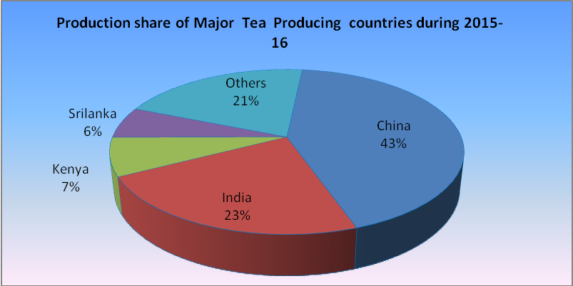

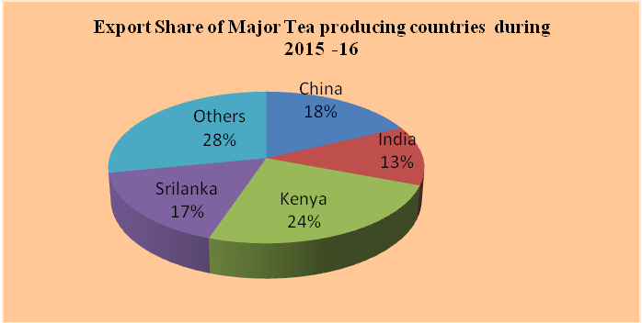
Source: ITC Annual Bulletin of Statistics 2016
The global tea production and consumption during 2015 was 5305 million kg and around 499 million Kg respectively. The table shows that India is the second largest tea producer (23%) in the world. Total tea production during 2015 increased by 109 mkg as compared to the year 2014.Meanwhile total global exports in 2015 decreased by 27 million Kg over 2014. However, India and China retained their leading position in the same order. The financial year 205-16 saw a record tea production at 1233 million kg and exports crossing 230 million Kg after 35 years valued at Rs 4,493 crore (Business standard, June 17, 2016).
The above data implies that India exhibits a steady growth momentum even in the backdrop of global slowdown and lower world demand. The pursuance of “Nairobi Package of W T O, paradigm shift of India’s’ trade policy, the facilitator role that has been playing by the Director General of Foreign Trade (DGFT) and Tea Board….etc play a significant role as a whole for the green shoots in production of tea and export growth in India during 2016.
Tea is one of the twelve sectors in India that recorded positive export growth in value terms during 2016. The most significant feature of the industry is its ability to provide direct employment to more than a million workers, of which a sizeable number are women. Additionally, more than six million people derive their livelihood from ancillary activities associated with the industry Even within positive growth momentum the cumulative tea production during 2016-17 (Apr-Aug) reached 611.29 M.kg, decline of 29.11 Mkg (-4.55 per cent) as compared to its corresponding period. North India production declined by 11.77 Mkg (-2.23 per cent) while South India production declined by 17.54 Mkg (-15.55 per cent) during the current period (Annual Report 2016-17, Dept. of Commerce GOI). But according to the 51st Annual Report, 2004-05 of Tea Board of India, a total of 118 tea gardens were reportedly closed between the years 2000-2005 that had affected 68,442 workers. In Idukki district, Kerala 7 tea estates and 6 factories are abandoned, in Thiruvananthapuram district 1 tea estate and 2 tea factories are abandoned while in Tamil Nadu there are four closed tea gardens. These estimate shows the situation in the sector is not hopeful as reported by the different agencies. The present study also tries to explain the pathetic situation of tea plantation workers in abandoned/ closed down estates in Idukki, Kerala.
4.3 Trend of Production and export of Tea during Post Reform period in India.
The Govt. of India introduced economic reforms since 1991 especially in the trade sector, therefore, in order to make out the impact of economic reforms on India’s tea sector a comparative analysis between post and pre-reform period is necessary. Tea in India is grown over an area of 600000 hectare (ha) which accounts for 16% of the total area under tea cultivation in the world (Facts and Figures of Agriculture in Kerala, Dec.2013). The Indian tea industry is having thousands of tea gardens spread across various states of India. But many of the plantations are abandoned or closed down due to various reasons. The most somber among them is the dilemma of social exclusion of the plantation workers owing to socio-cultural and historic factors, which in turn manifests in the form of a vicious circle of poverty (Dr Rajasenan and R Rajesh). A detailed account on trend of tea production and export during post reform period is inevitable because those data manifests a lot of information things. The following figure highlights the performance of tea sector during post reform period.

Table 4.2 Trend of Production and export of Tea during Post Reform in India

Trend of Production and export of Tea during Post Reform in India
(in Mkgs)
Year | Production | Export | Year | Production | Export | Year | Production | Export
1991 | 754 | 202 | 2000 | 846 | 206 | 2009 | 979 | 197
1992 | 732 | 174 | 2001 | 854 | 183 | 2010 | 966 | 193
1993 | 760 | 155 | 2002 | 838 | 201 | 2011 | 986 | 215
1994 | 752 | 150 | 2003 | 878 | 174 | 2012 | 1126 | 208
1995 | 756 | 167 | 2004 | 893 | 197 | 2013 | 1135 | 216
1996 | 780 | 161 | 2005 | 906 | 205 | 2014 | 1207 | 207
1997 | 810 | 202 | 2006 | 948 | 196 | 2015 | 1209 | 229
1998 | 874 | 210 | 2007 | 973 | 202 | 2016 | 1250 | 231
1999 | 825 | 191 | 2008 | 987 | 203 | -- | - | -
Source: Various Annual Reports, Tea Board, GOI
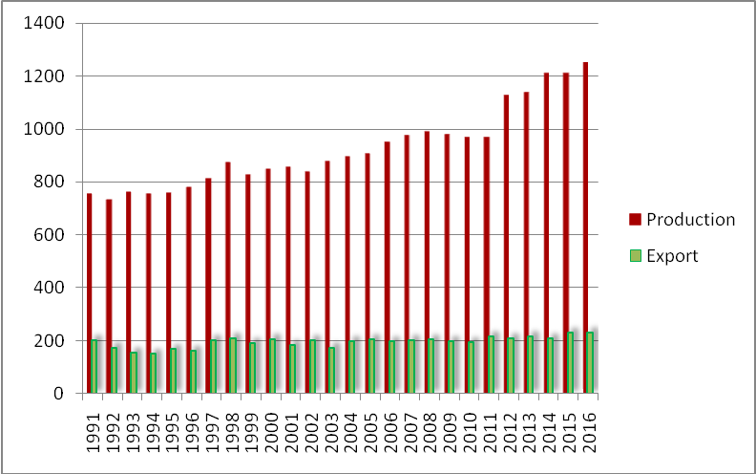
Looking at the performance of Indian tea industry in terms of production and export of tea, it can be seen that the production of tea lies between 754 Mkgs – 800 Kmg during 1991-1996. Later its production reached a range between 810 Mkg to 896 Mkg up to 2004.It is observed that the production of tea showed a gradual increase and volatility up to 2011. Since 2012 it shows an improved performance especially in 2016. In this year tea production has reached at 1250 Mkg (Table3.1) after a long thirty five years. It was found that there was 41 Mkg increase in tea production in 2016. But it is not a good performance compare to production in China 2278 Mkg against 2096 Mkg in 2014 (Table 3.1). At the same time currently, India produces 23% of total world production and consumes about 21% of total world consumption of tea –nearly 80% of the tea produced is consumed within India (A. Basu MajumderB., Beraand A. Rajan).
Initial stages of reforms tea export recorded contraction from 202 Mkg, in 1991 to 161 Mkg up to 1996. Later it reached at 202 Mkg in 1997. And in the next year, 1998 Indian tea export earmarked at highest figure 210 Mkg. Since 1999 to 2008 there was up and down movement of tea export .Of them 2003 showed lowest export. In the year 2005 there was marginally increase in export. During the period of 2007-2009 world economies, especially the developed nation like U S A was in the clutches of global financial crisis. But Indian tea export was more or less steady in that period. However, crisis and changes in economic policies were not peculiar to India alone at that time. It is evident that after 2009 there was steady growth of tea export and in 2016 tea production and export performance was milestone in the history.
4.3 Decadal changes in area, production and productivity of tea in India.
To analyse effect of economic reforms on tea sector in India a comparison between post reform periods is indispensable. Therefore researcher was made an attempt to examine the decadal changes of area, production and productivity of tea in India since 1951 to 2011. It was observed from Table 4.3 that changes in area, productivity and production gained over decades during 1951-1961. The lowest gain is marked against area of tea production. The nation gained area under tea towards the end of the decade. During 1971 to 2001, decadal change in area of tea was found to be more erratic in the country. Decadal change of production of tea was found to decline in the tea producing states in the last decade except in Kerala and it was found to gain marginally in the country (Udeshna Talukdar ,2016). Production of tea was found more erratic during 1971-1991 at national level. It was the result of positive change in productivity (2.2 % increases). But during the period 1991-2001 there was negative growth in productivity thereby the production also marked negative change. The last decade data highlighted positive growth in all three indicators. One of the notable inferences is that there was steady and stable growth in area of production, productivity and tea production during 1951-2011 except in some states.

Table 4.3 Decadal changes in area, production and productivity of tea in India
Year | Kerala |  |  | All India
Year | Area | Production | Productivity | Area | Production | Productivity
1951 | 33.2 | 25.8 | 776 | 316.8 | 285.4 | 901
1961 | 39.8 (1.99) | 39.5(5.31) | 994(2.81) | 331.3(0.46) | 354.4 (2.42) | 1070 (1.88)
1971 | 37.3(-0.63) | 42.7(0.81) | 1146(1.53) | 356.5(0.76) | 435.5(2.29) | 1221 (1.41)
1981 | 35.6(-0.46) | 47.6(1.15) | 1338(1.67) | 383.6(0.76) | 560.4 ( 2.87) | 1461 (1.97)
1991 | 34.7(-0.25) | 66.8(4.03) | 1926(4.39) | 420.5(0.96) | 754.2 (3.46) | 1794 (2.28)
2001 | 36.8(0.60) | 66.0(-0.12) | 1796(-0.67 | 510.4 (2.13) | 853.7 (1.31) | 1672 (-0.68)
2011 | 37.1(1.52) | 68.3(0.35) | 2180 (2.13 | 790.3 (5.48) | 988.3 (1.58) | 1925 (1.51)
Source: Tea statistics, Various Issues, Tea Board of India, Kolkata.
(*Figures in parentheses indicate annual decal change Area in ‘000 ha, Production in Mkgs, Productivity in kg/ha)
The data of some years showed a negative growth in all three indicators. The analysis related to economic reforms and its impact on Indian tea sector revealed that there were great constructive changes that occurred in the tea sector after reforms but the benefit of these changes not distributed among the plantation workers. That is the above mentioned positive changes are excluded the plantation workers. Increased number of abandoning of tea estates India especially in Kerala reveals deepening of crisis in the sector. Low productivity, declining trend of tea production area, price fluctuations in the sector …..etc dampening the positive changes in India Tea industry.

Chapter V

Socio economic condition of tea plantation workers during post closure period

Introduction
The second objective of the present study is to assess socio economic conditions of tea plantation workers in the study area. The present study is a micro level study. For that the researcher selected the plantation workers of Peermedu Tea Company, Idukki district, Kerala. Idukki district represents 67.50 percent of total tea plantation area of Kerala ( T V Ushadevi & V N Jayachandran). In Kerala there are 154 estates of them central Travancore has 36 estates. These estates owned by 16 companies are located in peermedu taluk. These companies spread over Peermedu, Upputhara, and Elappara panchayaths. The present study tries to explain the problems of tea plantation workers in the abandoned or closed down estates. In peermedu taluk 9 estates are abandoned or closed down. The researcher selected the estates of Peermedu Tea Company (technically two estates Peermade estate and Lontree estate, but functioning as one). Thus in the coming explanations it may be mentioned as Peermedu Tea Company or Peermedu Estate. It is located in 6 and 12 wards fully and 7,11and 15 wards partially of Upputhara Panchayath. Cheenthalar estate, part of the present Peermde Tea Company estate was established by British planters in 1830. The other part, Lonetree estate was established only after 85 years. Due to various reasons the company was closed down in 2000.
The crisis of the company was peak during 1998. One of the most important factors behind the closure was pending of various payments benefits to the workers. Besides these reasons the respondents shared other factors that led to the closed down of estate, mismanagement of the company affairs, conflict between trade unions with the company, lower productivity, improper caring and maintenance…etc. From 2000 to 2013 the workers united for their livelihood and divided tea bushes among them with the leadership and initiative of trade unions. They pluck the green leaves illegally and sell them outside. But the income from this source was inadequate to meet their needs. After thirteen years of closure the company leased out in November 2013 on contract base. But the new management said that it is a difficult task to operate the company. Thereafter immediately the management abandoned the estates. Thus the workers became in a deep trouble. As per the approximate estimation of workers many of them have to get around rupees 4000 -7000 from the new management. Before the closure there were 1300 permanent workers with equal number of temporary workers. But now almost all workers resort other sectors for their livelihood. According to the workers the present system of selling of tea bushes also exploitation. Because they did not get actual price for tea bushes. The distribution of tea bushes aims to bring additional income source for the households. Each family would be allotted 1300 to 1700 bushes with one and half acre of land for their livelihood. Many of the workers migrated to other sectors because they cannot survive with the income from estate.
This crisis has not just affected the owners of the tea estates who are recuperating from their losses but as far as the workers and their families are concerned, they are thrown into worse-off situations of extreme vulnerability especially women, children and the aged. The strange problems that they facing are lack of basic infrastructure like medical, education and other facilities and overall earnings have resulted in deaths due to starvation, suicides and have compelled children to drop-out from schools. Another notable issue is wide encroachment of company land. There has been a terrific increase in out-migration of a specific age-group from families of tea workers in search worthwhile jobs in cities and nearby towns from the tea growing areas. The remaining population of tea families is mainly the aged and infirm and young children thereby leaving them to situation of total helplessness and deprivation. The present study takes on certain indicators to analyse socio economic conditions of tea plantation workers in the study area. In order to examine the pathetic situation of tea workers the researcher selected 341 workers from 90 households as sample. In the company there were 1300 permanent workers along equal number of temporary workers. But today the number of permanent workers has been contracted to 493. Thus from total population of 493 members researcher selected 341 as sample size. For the completion of study surveyed 90 families. There is no record having exact number of workers in the study area after the closure of estate in 2000.

5.1 Age-wise Distribution of employed members of Sample Workers’ Households

Human resource is an imperative factor for every industry to build up their industry. Compared to all other resource its role in the development of industry is crucial. In tea plantation Industry both male and female workers are engaged in both permanent and temporary basis. One of the major issues in plantation sector is labour shortage, which has been become a serious impediment to the survival of the sector in India too. The present labour shortage is induced mainly by a wage shortage. And in many plantations wage and other benefits is not regular. The planters try to adopt casual and temporary labour as much as possible, delayed the process of confirmation of temporary workers to permanent employees. Thereby the coming of new generation is also smaller amount for a few decades. Thus planters face a situation of labour shortage due to increasing aversion of workers’ family members, especially youngsters, to plantation labour. The table 3.4 shows age distribution workers in the study area. Majority of workforce is from the age group of 41-50. Likewise the lowest contributions from younger generation at the age group 17-30. It revealed that the new generation is least interest in the sector. Total workers in the District categorized under main workers and marginal workers are 516363. Number of main workers in the District is 415947 and marginal workers are 100416. Total workers are categorized as cultivators, agricultural labours, household industry workers and other workers. Female participation in the work force in the District is around 35.76 percentages. But in the working force under marginal workers females are more in number than males (Census 2011).
Table 5.1 Age-wise Distribution of employed members of Sample Households
Age Group | No. of People | Percentage
17-30 | 30 | 8.7
31-40 | 84 | 24.6
41-50 | 150 | 43.9
51-55 | 32 | 9.3
56-60 | 41 | 12.02
Above 60 | 4 | 1.1
Total | 341 | 100
Source: Primary Data
5.3 Educational status of Sample family Members
As a state like Kerala educational attainment has a great role. In Human development Index estimation it plays vital role. Generally of plantation workers especially tea workers are migrant labourers, with different mother tongue, customs and educational level. The percentage of illiterates comes to 14.9. Illiterates are more in Tamil families. Majority of the members have dropped their study at Secondary Level. (Table3.5). Though 11.4 percentage of members passed secondary level, only a few become lucky to pace foot at College level. The remaining part either fails or drops out at Pre-degree or Plus Two classes.
Table 5.2 Educational status of Sample family Members
Educational Level | No of People | Percentage
Below age 5 | 31 | 9.0
Illiterate | 51 | 14.9
Primary | 75 | 21.9
Secondary | 145 | 42.5
Above 10 | 39 | 11.4
Total | 341 | 100
Source: Primary Data
Usually the parents are not willing to provide better education to their children. Because the financial difficulties of parents, the ignorance of parents with respect of education, the remoteness of place of residence and long journey needed for better education are reasons behind the educational backwardness of these areas. There is a Government high school at Kattadikavala, in Peermade estate. But the parents are not sending their children to the school. In the panchayth there are 7 Lower primary schools from government (3 nos), local Panchayth (1 no) and private sector (3 nos). In the same way there are only two higher secondary schools within the panchayath (Census 2011). Besides students have to travel long distance for their higher education. Because of these factors as well as their negative attitude towards education, their own cultural social, linguistic background also acting as impediment to education.

5.4 Community wise Distribution of Sample Households
The detailed survey from 90 households from the study area reveals that the two major categories of people are Ezhava and CSI (Table 3.6). Both of these categories together contribute 44% of total households. The next most important community is Pentecost 13%. In the study area bulk households were belong to scheduled caste earlier later they converted to different Christian communities as CSI, Latin Catholic, Pentecost etc. As in the case of all most all tea estates Kerala here also have linguistic minority group from Tamil Nadu. Out of 90 surveyed households about 42 households have Tamil Nadu background.

Table 5.3 Community wise Distribution of Sample Households
Community | No of families |  | Percentage
Ezhava | 22 |  | 24.4
CSI | 22 |  | 24.4
Latin Catholic | 4 |  | 4.4
Marthoma | 3 |  | 3.3
Nadar | 3 |  | 3.3
Nair | 3 |  | 3.3
Pentacost | 12 |  | 13.
Pulayar | 4 |  | 4.4
Roman Catholic | 2 |  | 2.2
Sambavar | 4 |  | 4.4
Parayar | 4 |  | 4.4
Thevar | 7 |  | 7.77
Total | 90 |  | 100
Source: Primary data

5.5 Share of Different Sources of Income of Sample Households (Percentage)

This type of analysis is necessary to understand workers sources of income. Currently majority of workers in the study area not depend on plantation work for meeting their day to day needs. At present the workers have completed seventeen years of miseries. Casual observation suggests that, in some spaces, the quality of in the study area has worsened. This is undoubtedly related to the liberalization of entry in to the sector. In addition to these there were existing different types of exploitation within the estates. Certain problems are common to women workers. A Comprehensive approach to the problem of women is put forward by (A.K.Sen, 1992).There is a difference in wage, benefit, bonus between male and female. Indeed in the context of intra household divisions, it is not easy to split up the total household income in to the incomes going respectively to different members of the family (T V Usha Devi and Vinaya Chandran, 2003) . Now they cannot stay alive with the income from their allotted tea bushes. The different sources of income are detailed in the following table. In 2001, 74 percent of the workers in closed down Peermade Tea Company engaged in plantation work-plucking and selling out of green tea leaves by themselves-as primary occupation, contributing 56.43 per cent to the total income of households (ibid).

Table 5.4 Share of Different Sources of Income of Sample Households (Percentage)
Source of income | Percentage
Plantation | 34.04
Plantation(Overtime work) | 0.6
Agriculture | 1.9
Agriculture labour | 5
MGNREGP | 2.3
Wage labour in non-agriculture | 46.4
Animal Husbandry | 2
Wage employment in trade/business | 2.3
Self-employment | 2.2
Professional/governmental | 1.26
Maid/home nurse | 2

Source: Primary data.
This evaluation also reveals the fact that workers are dissatisfied with existing wage rate in tea plantations. This relative share of Mahatma Gandhi National Rural Employment Guarantee Programme (MGNREGP) in the total income is only 2.3 %. While only 34% of income is contributed by the plantation sector. This figure gives a clear idea about the reluctance of workers to stay on in tea estate sector. Another important inference from the survey is that about 46.4 % of income from non-agriculture sector. After sixteen years of abandonment of tea estates the workers have to move to other districts forcibly. The low figures of self employment, agriculture income explain that after the closure of estate they still depend on plantation sector but the earning from there not sufficient to meet their needs. Approximately 13.5 lakh plantation workers employed in the region Tamil Nadu, Kerala and Karnataka. They are not optimistic, it is very clear from their responses. Many of the age old workers still live with the good memories of earlier happy life in the estates. They said that before closing each and every need would be settled by the company itself.

5.6 Residential facilities
As per various records the crisis started in study area was in 1998. Actual reason behind the closure is unaware, told by women workers. The pending of the disbursement of bonus, leave with wages…etc cemented the way for starting protest and strike by the workers against the management. Later there was continuous protest against management that disturbed the smooth functioning of company. Consequently the management had lost interest on the company. Thus company was also started strategic game by withdrawing company’s employees time to time. In this way the company withdrew the last employee from the estates in December 13, 2013. It was a great stroke to the workers. Thus their misery becoming unsolvable, they realized that their life fell into deep crisis and it till continues. In this context the residential status should be analysed to explore the pitiable situation of workers in the study area.
Recently the dismal situation of tea plantation workers in Peermedu Tea Company has got national level attention. And a team of central ministry has planned to visit the company. There were some initiatives and discussions made under the leadership of Sri Shibu Baby John, Minister for labour, Govt. of Kerala during the period of United Democratic Front (UDF) ministry. But they failed to materialize their offerings. The latest Left Democratic Front (LDF) has been taking steps to help tea plantation workers of Peermedu Tea Company. As the part of LDF govt’s attempt and pressurized movement of trade unions many declarations have been made by the Kerala govt. One of them was special package for homeless tea workers. Another important step from government was the visit of Sri T P Ramakrishnan, Minister for Labour , Govt. of Kerala, in October, 2017 in the closed down estates of Peermedu Tea Company. The minister said that the existing life situation is terrific and there is a need of combined effort and support from different department of ministry. In the light of minister’s visit the officials of labour department visited the study area and estimated requirements of workers. And minister said that his department will take initiative to solve the problems of workers. Similarly the chief plantation officer also conducted a detailed study recently and submitted a report before the government.
According various reports there are 321 lines are needed to immediate renovation. Currently 75 lines are bowed completely. In the conclusion of report they suggested that the collapsed roof of the lines should be replaced with strong iron cadre roof. For that expected cost is Rs 2.5 crores. Many workers have constructed a temporary settlement in the barren land of the company. Some others are still live in partially collapsed line with the hope of a solution for their problems in the near future. But the workers responded that many workers and outsiders are encroached the land of the company. The study report of Labour Department estimated the no of families who are living in the estate as follows.

Table 5.5 Division-wise Estimation of Families in 2017
Name of Estate | No of families
Cheenthalar Division I | 64
Puthukkada Division II | 97
Division III | 65
Lonetree | 51
Total | 277
Source: Report of labour Department, Govt. of Kerala 2017
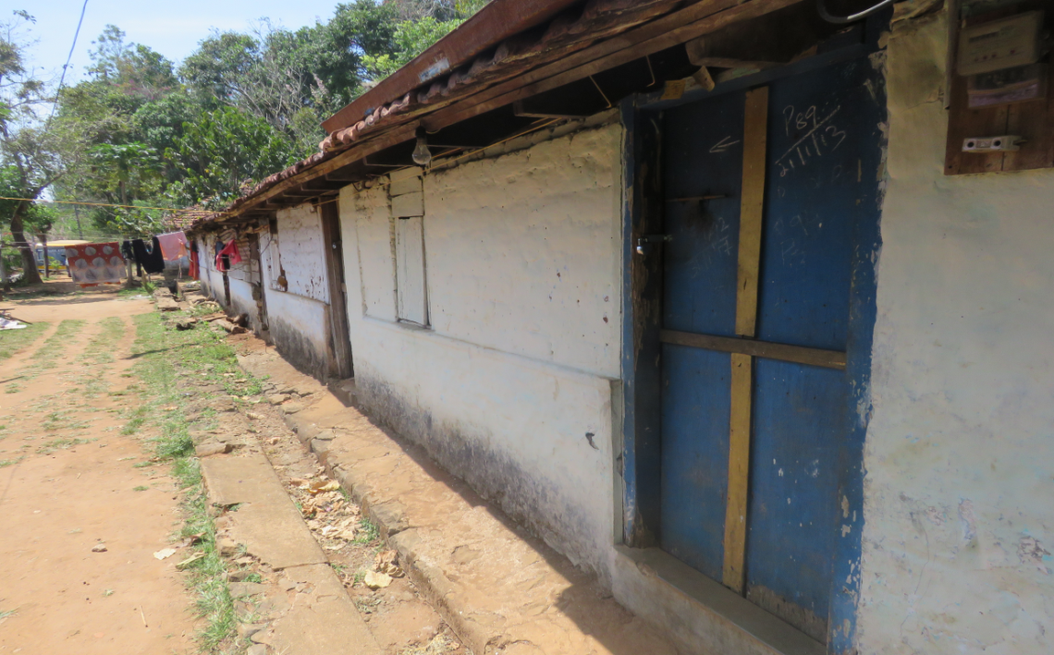
During the time of minister’s visit all workers were requested that they need a complete solution for their misery. They were not supporting leasing out of company. They also demanded that government should take over the company immediately. At present a small number of workers halt at estate lines. Most of them do not have own house and land outside the estate. Therefore they stay here with strong believe that the reopening of the company in coming days. Majority of lines are not in a position to subsist with present condition. Photo : Cheenthalar Estate

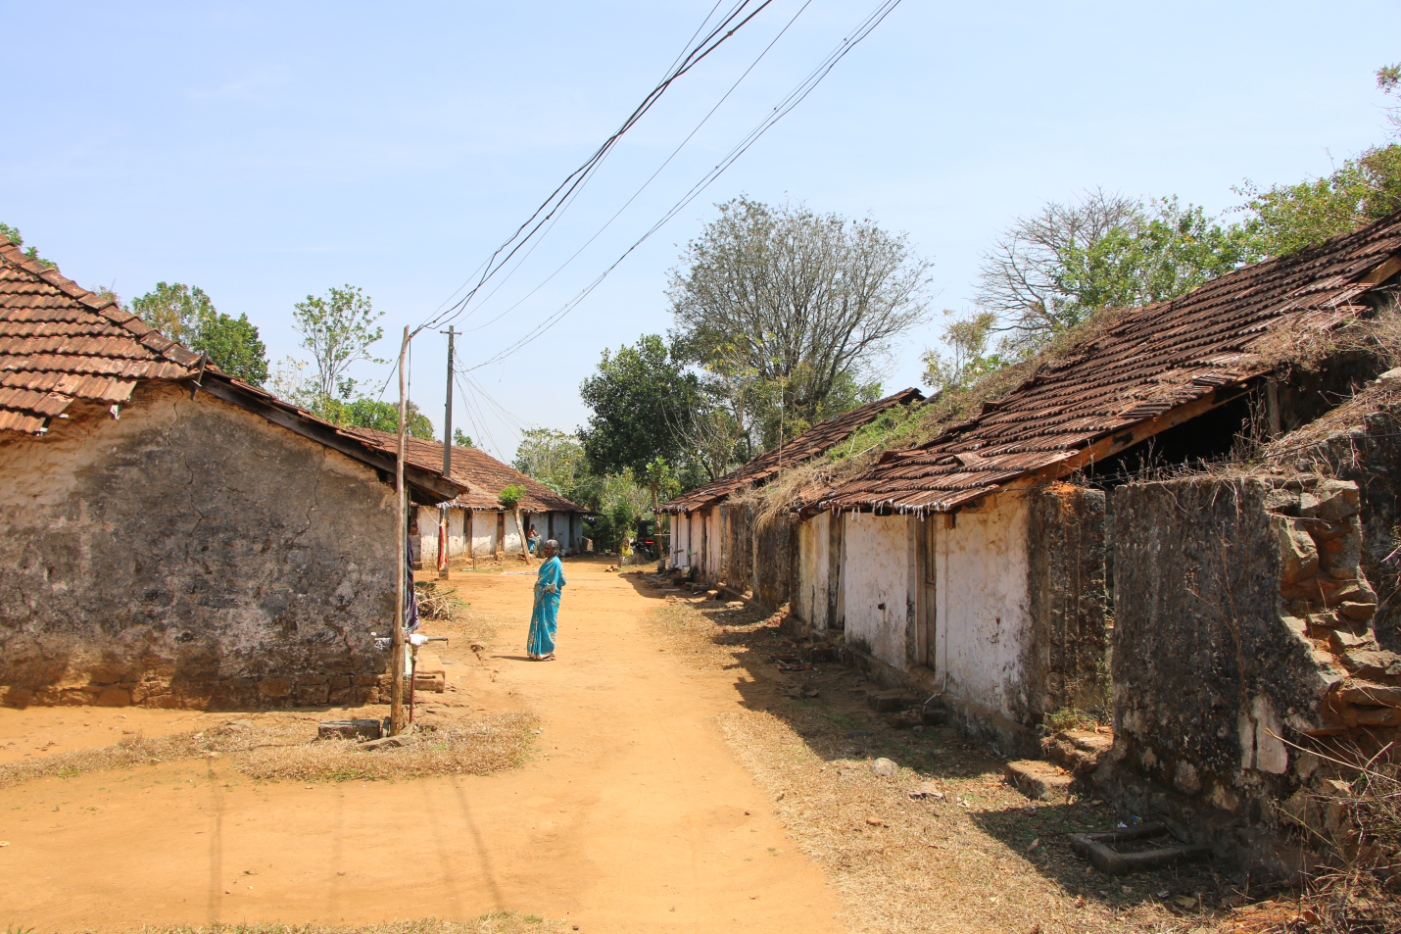
Photo : Estate Line at Lonetree

5.7 Indebtedness of workers.

Indebtedness is another common problem of plantation life. It is upsetting day to day life of workers precariously. Though it is a widespread problem in tea plantations but in the study area indebtedness is at dangerously. The following details express the financial burden of plantation workers in the study area. The survey exhibited that only 35% of households were borrowed from organized sector of the economy the rest (65%) resorted to unorganized sector of the economy (survey data). It means that they have been paying large amount of money as interest. This again intensifies their financial problems. This situation represents another dilemma that they are facing. That is why they cannot resort organized sector for borrowing because they do not have any sound securities and even many of them do not have even bank account. There is no doubt that the existing houses need to be upgraded. The increased price for construction materials and labour charge are also impediments to renovate their homes.
5.8 Non-Payment of Wages

It is another impact aroused due to the closure of the company. Irregularity of wage payment is the basic issue of all tea plantations in India. Many of them have not paid wages to the workers since October, 2000. Some others have not received wages during 2013-2014 when the company leased out (an average of Rs 4000- 7000 is pending during this period).
5. 9 Problems faced by the workers after closure
Almost all Payments of wages have turn out to be irregular and at times uncertain the wage rate has been cut down. Besides bonuses have been cut and many workers were retired without retirement benefits such as PF, gratuity and pension. South India’s plantation industry pays one of the highest basic wages and it was as high as Rs 232/- for the tea plantation workers in Kerala. But according to C Vinayaraghavan former Chairman, Association of Planters of Kerala, this portion is not sustainable. Cuurently the wage rate is reached at Rs 320/- in Kerala.
Another common problem that the workers faced during post closure period of Tea Company was many services like ration, health, education, and water supply have suffered drastically and, as a result, the quality of life has dropped. Various studies reported that the cases of premature death are common during this period. Many of the age older people are suffering from various diseases. They are unable to meet treatment expenditure.

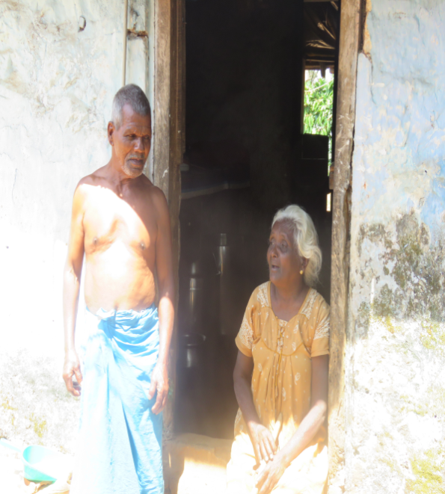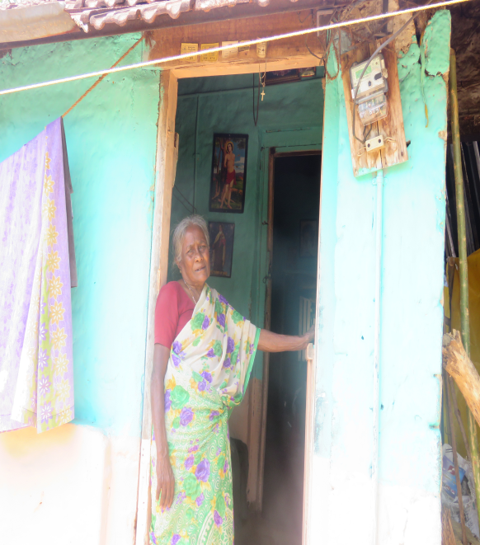
Since the garden is relatively isolated, alternative employment opportunities are almost absent. Usually tea plantation workers are not educated or skilled thus they were struggled to find out a new job outside the garden. This explains why mobility is low in this garden. Repair works of workers’ houses have been neglected by the authorities and owners of the company. Before the closure of the company the owners were ready to do maintenance work even within days, some workers responded during the field visit. Many workers were migrated only because of the poor quality of their lines. Most of them are under threat of fall down. During the rainy season the workers could not even sleep. Thereby the students were unable continue their study. At the same time the income of the workers was not sufficient to do such maintenance work.
The tea bushes are old and are damaged as they are not getting proper manuring. At present they are not tea plantation workers because they nurturing only their own tea bushes that distributed under the direction of trade unions. But currently the non-cultivating households are more in number due to nominal price for their product. The intermediaries are taking the advantages of their hard work. Another interesting thing is that many workers have transferred their allotted tea bushes to others for cultivating. Some workers said that their life before the closure was superb compare to present situation.

The drinking water is an essential requirement for everybody. At present the workers have water connection operated by the panchayath. They said that the public tap connection is very helpful but most often they failed to pay monthly water charge of Rs 100/-..
There is a clear evidence to show that the plantation sector has been not capable to provide any net addition to employment during 2001-2016. For males, the plantation sector has been stagnant. But the non-plantation sector has not been adequate to compensate for the decline of employment in the estates.
. Looking across tea estates, happiness disappeared among tea workers. An age old worry is that, many of them are already reached at retirement age. If the company continues the present status for a long time their life will lead to rigorous insecurity. Thinking about the company side we may be interested, various assets including two factories, land, two bungalows, quarters, estate lines, machines, equipments….etc have been condemned for the last sixteen years.
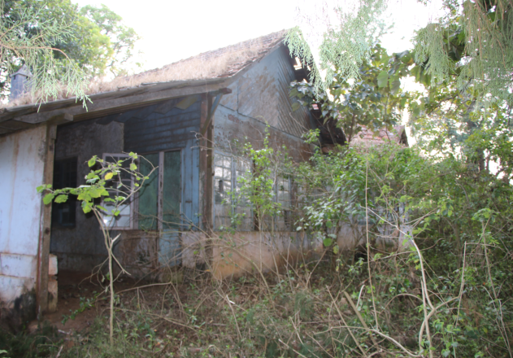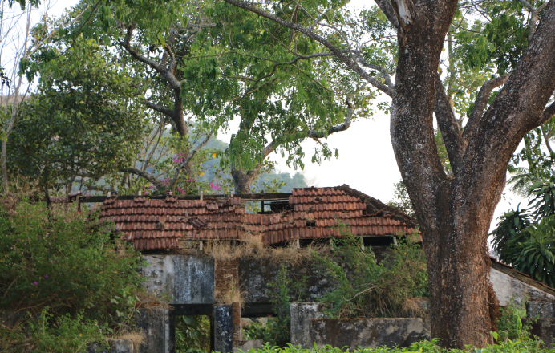
Photo : Company Quarters

The following photographs show the two factories of the Peermedu tea company. These two factories are just like monuments of Peermedu Tea Company. They remember the golden age of the company. Some workers added that the companies were working for twenty four hours. The workers had arranged the duties in different shift. Thus they were the strong force behind the success of company before its closure.

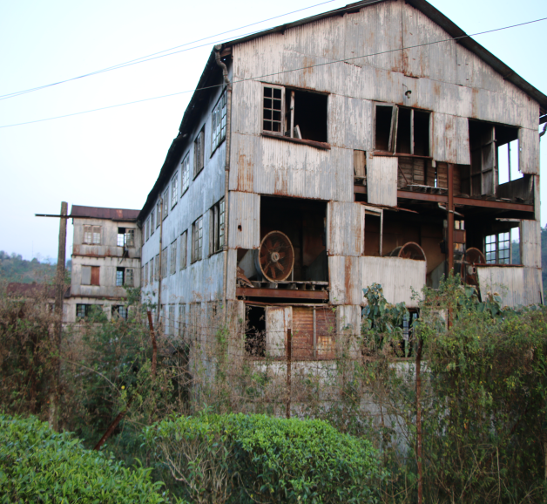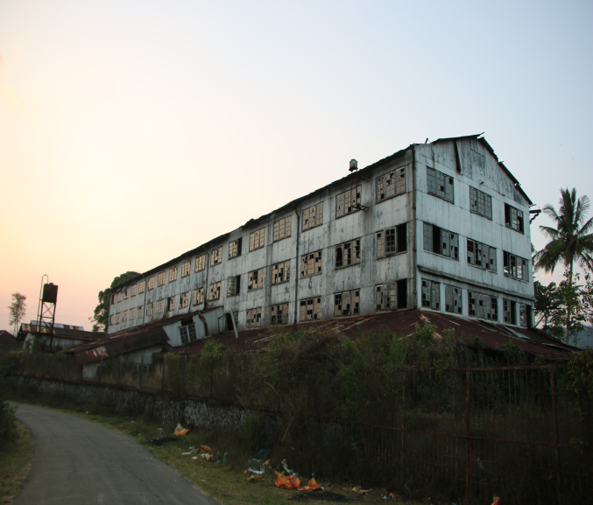
Photos : Tea Factory at Kattadikkavala Tea Factory at Lonetree

Many workers and non-workers have encroached company’s land for cultivation and other purposes. Assets like factories, bungalows, quarters…are irreparable today. If the company reopens, there is a need of huge amount for repairing of factories, quarters, machines, equipments…etc. Similarly almost all are believed that the reopening of factory never happens. Thus the workers and public steal valuable items of the company. Many items in the quarters and the tea factories of the company have stolen. As per the words of supervisor, furniture, curtain, machines, equipments, trees..etc has been looted. As a whole the abandoning of the company becomes resource wastage to the nation in many ways.
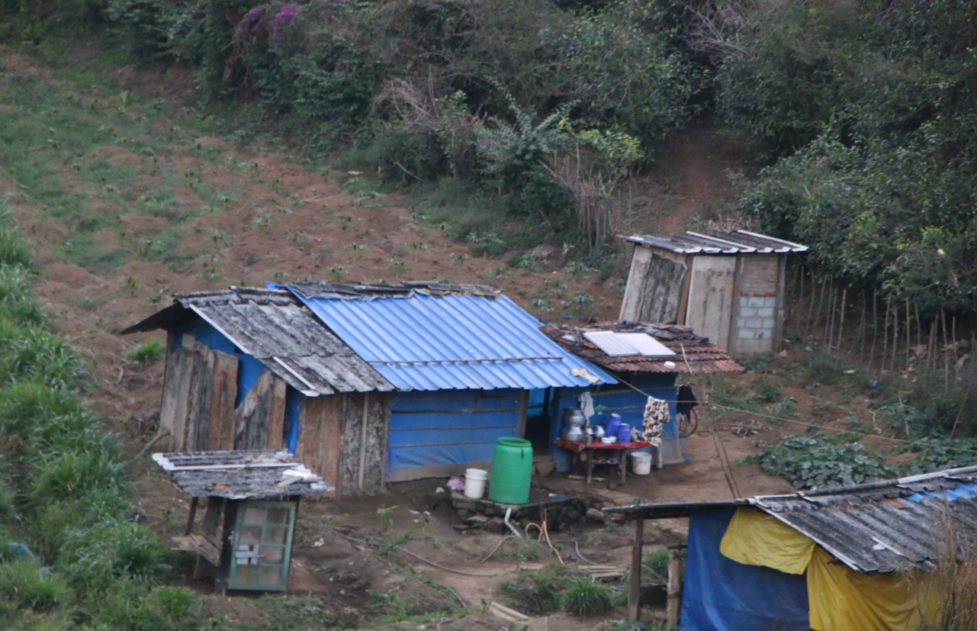
Temporary settlement for cultivation in company’s land.

It is important to address there were a lot of people resorted the company for achieving livelihood in the past. Many non-workers had tea shops, stationary shops, other business, ration shops, chit funds…etc. Now such facilities do not exist. No scope for additional income generation opportunities. In a nutshell abandoning/ closure of Peermedu Tea Company have been created much socio-economic, cultural and political impact on the local economy of Peermedu as well as in Idukki district.
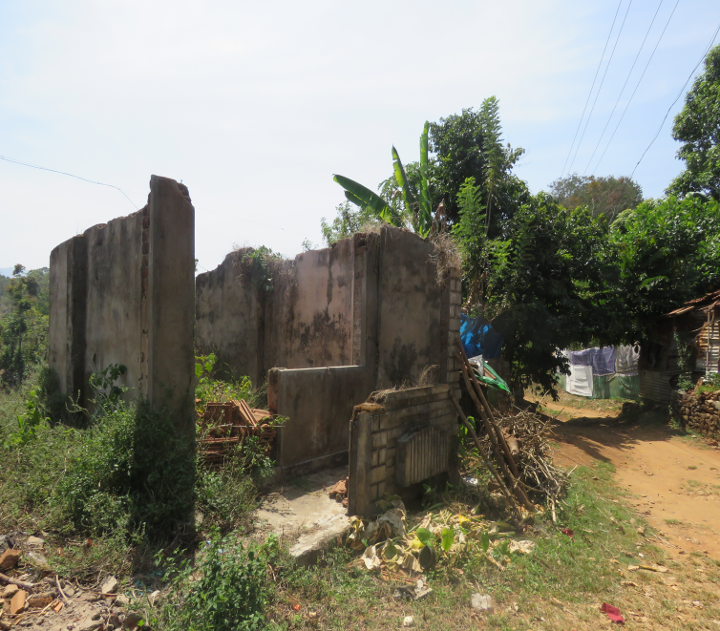
Old tea Shop
The crisis in tea plantation is a multidimensional issue. It cannot be evaluated simply. The present situation of the company is pitiable said by many workers. They also added that head-stone behind the crisis is unaware to them. Mean while some others hope to continue the present situation for ever. This situation arises only because of the conflicting interests of the people. The net result will be the worsening of socio economic conditions of tea plantation workers. Loss of shelter tends to be only temporary for many resettlers; but, for some,homelessness or a worsening in their housing standards remains a lingering condition. In a broader cultural sense, loss of a family’s source of income and the loss of a group’scultural space tend to result in alienation and status-deprivation.

5.10 Abandoning of Tea Plantations and its impact on Authorities
As discussed above the crisis in tea plantations had affected plantation workers as well as the owners. Another group of losers are different levels of govt. authorities. The central, state and local authorities have been lost lakh of rupees as different taxes. In case of Peermedu Tea Company, it was abandoned or closed in 2000 and many plantations are experiencing severe catastrophe in Kerala. The present trend in the sector is not hopeful because at any time the companies may shut down. In this context, there is a need of immediate solution to solve the disaster in plantation sector. The following table shows different types of taxes which are applicable to plantation sector.
Table. 5.6 Loss of Revenue from Tea Plantations to Govt. Authorities
Centre | State | Local Bodies
Income Tax | Agricultural Income Tax | Sanitary Tax
Cess under the Commodity  Act | Professional Tax | Lighting tax
Cess under the Commodity  Act | Land Tax | Drainage Tax
Excise Duty | Sales Tax | License Fee for Machinery
 | Factory License Fee | Water Tax
 | Central Sales Tax | Professional Tax
 |  | Building Tax

It is evident that, the possibilities of income generation from tea estates of Peermedu Tea Company have been lost for the last sixteen years. In total the crisis in tea plantations has affected local economy as well as state and central governments in many ways. But the depth of actual impact of such crisis cannot be measured in monetary terms. It has various social implications.

Chapter VI
Findings, Suggestions and Conclusions

The field work provides an opportunity to understand micro-level information of wide variety of socio-economic and political problems of tea plantation workers. The study offered the opportunity to understand the real nature and complexities of the crisis in tea plantation sector.The primary data from 341 respondents collected from 90 families through questionnaire and were analyzed using simple statistical method. It has been interpreted that
6.1 General Information: Of the total workers, 8.7 % of the respondents are ‘17- 30’ years of age, majority of them are female workers. Whereas 24% of the respondents are ‘31- 40’ years of age, 43.9% of the respondents are ‘41-50’ years of age, 9.3 % of the respondents are ‘51-56’ years of age and 12.02 % of the respondents are ‘56-60 ’ years of age. And only 1.1 % of the respondents are above 60 years of age
6.2 Educational Status: Low Educational attainment is an important impediment for plantation workers. In the study area majority of workers (43 %) have secondary level education. There are 21% of workers are illiterate. And 11% of workers attained above 10 level educational attainment. Meanwhile 25% of workers qualified only primary level education.
6.3 Community wise Distribution of Workers: The detailed survey from 90 households from the study area reveals that the two major categories of people belong to Ezhava and CSI. Both of these categories together contribute 48% of total households. The next most important communities are Pentecost (13%), Thever (7%), Pulayar (4%), Latin Catholic (4%). And Marthoma, Nadar, Nair, Roman Catholic contributes an average of 3% each. In the study area bulk households were belong to scheduled caste. In course of time they converted to different Christian communities as CSI, Latin Catholic, Pentecost etc. As in the case of all most all tea estates in Kerala there is also having linguistic minority group from Tamil Nadu. Out of 90 surveyed households about 42 households have Tamil Nadu background.
6.4 Present Income sources of Plantation workers: Out of 90 families only 34% of families depending on plantation as main income source. About 46.4 % of families resort non-agriculture sector. Agriculture labour constitutes 5 %. Another major income sources are animal husbandry (2%), MGNREP (2.3%), self employment (2%) and home nurse (2 %).Most important fact is that only 1.2 % of plantation workers family have government employees.

6.5 No scope for additional income generation opportunities
It is important to address there were a lot of people resorted the company for achieving livelihood in the past. Many non-workers had tea shops, stationary shops, other business, ration shops, chit funds…etc. Now they do not exist. And the existing small traders receive only meager amount of income. Smt Lakshmi permanent worker of the company at Puthukkada division told that before the closure she had Rs 4000/- as daily income from her small shop. But today it is less than Rs 1000/-. Due to this situation majority such small traders in and around of Peermeddu Tea estates have nowhere to be found.
6.6 Non-Payment of Wages and other Benefits.
About 85 % of surveyed workers have to get their rights as wages, gratuity, bonus …etc. It is another impact that aroused due to the closure of the company.
6.7 Interim alternative resolution
After the closure the company under the leadership of all trade unions 1000-1500 tea bushes and half acre of land distributed to permanent tea workers. But about 65 % of tea plantation workers are not using these facilities in effect. The reasons are poor yield, high cost of production, low price for tea bushes, increased no of stealing …etc.
6.8 Poor residential facilities.
As a whole, at present there are only 277 families staying in the tea estate lines. Before the closure there were about 3000 thousand workers. The recent division wise estimation of families by the labour department, Govt. of Kerala exhibit that no of families as follows in division I Cheenthalar estate (64), in division II Puthukkada (97 ),idivision III (65) and in division VI Lonteree 51 families. According to various reports there are 321 lines are needed to immediate renovation. Currently 75 lines are bowed completely. As per the report of Labour department, Govt. of Kerala there is a need of s Rs 2.5 crores for repairing estate lines. And these estate lines are not having basic facilities to live.

6.9 General observations on vulnerability of Closed Tea Gardens
There were many social impacts of closure of the company cannot be viewed in a simple manner. Because abandoning of the company caused to forced displacement, drop out of students, large no of migration, moved out additional income from cattle raring, running shops, chit funds, social exclusion, poverty among women aged households, encroachment of company’s assets…etc.
Normally hospitals are utterly run by the management of the plantations and the doctors, nurses and health assistants are paid by the management and medicines are provided by them too. At present in the study area hospital is not functioning. As per the responses of tea plantation workers the hospital was sufficient for their needs. Many of the plantation workers surveyed born at that hospital. At present there does exist a skeleton of the hospital.
The drinking water is an essential requirement for everybody. At present the workers have public tap connection operated by the panchayath. But the public tap connection got recently. They said that the tap connection is very helpful but most often they failed to pay monthly water charge Rs 100/-.
There is a clear evidence to show that the plantation sector has been unable to provide any net addition to employment during 2001-2016. For males, the plantation sector has been stagnant. But the non-plantation sector has not been adequate to compensate for the decline of employment in the estates.
In addition to these abandoning of tea estates also created some other problems like job-loss and nonexistence of alternative source of income, malnourishment, added trouble on women, children, lack of right to housing, lack of right to land, In total abandoning or closed down of tea estate causes to overall degeneration of plantation areas in many respects.
6.10 Suggestions
The present socio, economic and cultural life of tea plantation workers in the study area is pitiable today. Thus there is a need for strong intervention of different levels of govt. authorities. In order to solve the current issues of workers tea estate should be reopened immediately.
Crisis in tea plantations is not a regional issue. It is a nationwide common issue. Therefore finding a solution for the issue is a urgent one.
Educational status of tea plantation workers is very poor and there is existing higher number of drop out among children. Thus the authorities have to be formed a special wing to improve the same.
Almost all assets of the company have damaged today. The authorities and the management should begin various steps to protect the assets. Otherwise crores of rupees will be lost.
In order to study the crisis in the Tea Plantation Industry government has to be brought a separate judicial committee.
The Plantation Labour Act of 1951 and the other Kerala Labour acts have to be amended properly to ensure the welfare of Labour side also.
Minimum wage should be revised in accordance with the changes in general price level. The present wage rate is very low compared to other sectors of the economy.
Government has to ensure a minimum price for the tea bushes. Thereby the exploitation of the intermediaries can be avoided.

6.11 Conclusion
I hereby conclude that the study discloses that there is clear degeneration of plantation workers in abandoned or closed down tea estates. The socio economic situations of tea plantation workers of the Peerumedu Tea Company have been worsening day by day. They are socially excluded community. Before the closure they had a better life compared to the present situation. Currently they are not in the status of plantation workers technically. The income from tea estate is not sufficient to meet even basic needs. They are leading to poor socio economic status. Currently a large number of their family members have migrated to outside the district in search of alternative sources of livelihood. For the last sixteen years the company was failed to provide lives and livelihoods to the workers. Looking across tea estates, happiness disappeared among tea workers. An age old worry is that, many of them are already reached at retirement age. If the company continues the present status for a long time their life will lead to rigorous insecurity.
Thinking about the company side we may be interested, various assets including factory, land, bungalow, quarters, estate lines, machines, equipments….etc have been condemned for the last sixteen years. The entire land area of the company is using inefficiently. Other major losers are the local authorities; they lost lakh of rupees as various tax and non-tax revenue for the last sixteen years.
Besides many small scales traders nearest to tea estates have vanished. Thus the social, economic and political effects of these cumulative crises in plantation sector have been dramatic. The social life, customs, culture...etc of plantation workers are intricately woven around plantations life since their birth. Today Indian plantation workers have been losing their own traditional way of life. They became an isolated society in our society. The so called mainstream society and the authorities have been doing only the role of spectator.

References
Anand, Neena, 2003, "Working Women: Issues and Problems",
Gill Sucha Sing (1998), Migration of labour in India.
Our Rights and Duties two sides of the same Coin, Ministry of I and B printing, Government of India, Calcutta (1991).
Drought in Maharashtra, Bombay, (1974
M.G. Srinivasan,( 2016) , A Study on Problems of Tea Plantation Workers in Nilgiris District Tamilnadu, India,
Techno Economic and Socio Economic Survey of Kerala Tea Industry, Tea Board of India , 2001
Joseph Merlin (2001), Problems and Prospects of Tea Plantation Industry in Kerala
Krishnan Lakshmi, (1996), 'Tea Exports, Regaining Lost markets,Chartered
Financial Analyst,
Kochhar, S.L. (1981), Economic Botany In the Tropic ...Macmillan India Limited, Madras.
Government of Kerala,(1991), Economic Review, State Planning Board, Thiruvananthapuram.

Government Of Kerala, (2001), Economic Review, State Planning Board, Thiruvananthapuram.
Government Of Kerala, (2011), Economic Review, State Planning Board, Thiruvananthapuram.
Udeshna Talukdar (2016), Dynamics of Production and Export in Transformation of Tea Plantation Sector in India.

Kumar Ajith, P.K. and Devi, I.P. (1995), Variability and trends in area, production and productivity of tea in Kerala, Agric. Situation in India, Feb: 807-809
Annual Report (2016-17), Ministry of Commerce and Industry Dept. of Commerce.
World Tea Production and Trade Current and Future Development, Food and Agriculture Organisation of U N O, 2015.
CEC Working Paper, Behind Closed and Abandoned Tea Gardens Status Report of India, 2007.
Narayanan, Sankara K.C, Karunakaran, V, 1985, Kerala Economy, New Delhi, Oxford.
George K.T, 1983,"The Economics of Tea Plantations in South India", PhD Thesis, Cochin University of Science and Technology (CUSAT), Cochin.
Yojana, March, 2015 Vol: 47, No: 3.
Various News Report, the Hindu Daily, 2013-2017
Various News Reports, Mathrubhumi Daily, 2013-2017
Various News Reports, Manorama Daily, 2013-2017
Various Annual Reports of Tea Board, Govt. of India.

